7. QUIZ COMPETITION – 25th September 2019
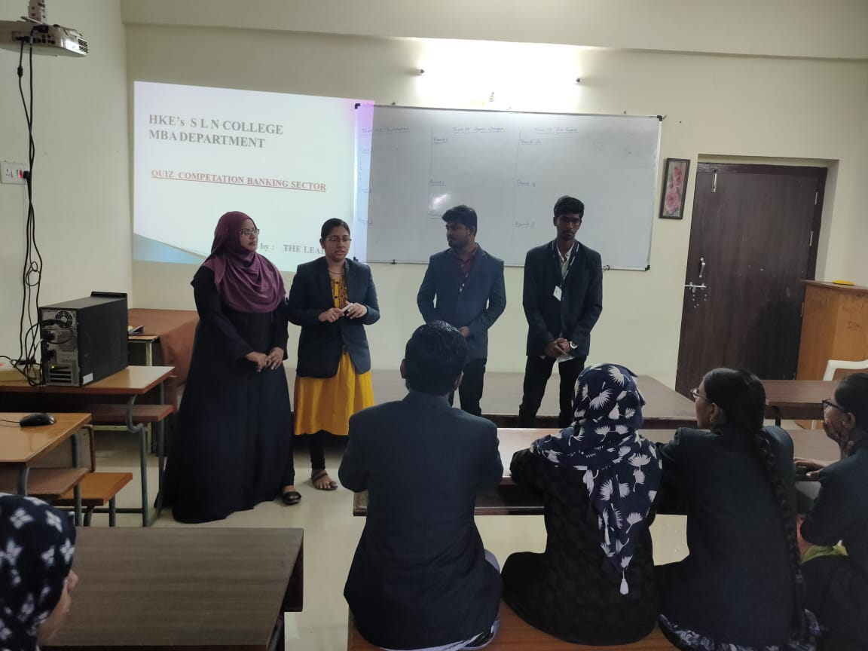

The QUIZ Club, Department of Management studies has conducted Quiz competition for the academic year 2019-20. The Club introduced Industry / Sector wise Quiz among the MBA Students. The students learned various concept related to Industries through Quiz Competition. The Quiz held on 25th September 2019.

