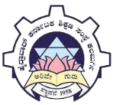
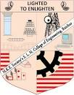
pa
HKE Society’s SLN College of Engineering
Department of Electronics and Communications Engineering
Date: 18-08-2023
Report on
Students visit to GTTC Kadechur, Yadgir
40 students of the department of E&CE along with 8 faculty members visited “Government Tool Room and Training Center” on 17-08-2023.
Students along with staff members got chance to see various laboratories like PLC Lab, IOT Lab, Manufacturing Automation Lab, CNC Lab, Electrical Lab, English Language Lab, etc.
Faculty of GTTC explained lab facilities available and demonstrated various experimental setups.
The visit helped students in learning about latest industrial standard lab setups and will enable them to make decision on taking up internship.
The visit was coordinated by Dr Vishwanath P, HOD E&CE and Principal of GTTC Kadechur, Yadgir.

