H.K.E. Society’s S.L.N. College of Engineering
Yeramarus Camp, Raichur.

Alumni Meet
The first virtual meeting of S.L.N College of Engineering Alumni was conducted on 18th July, 2020.
In the alumni meet Principal, Faculty members from various department and more than 45 Alumni were present.
In the beginning, Dr. R. Basavaraja principal of S.L.N. College of Engineering welcomed all the members to the virtual alumni meet followed by Prof. S.S. Bale president of alumni association as given the key note address on the constitution of Alumni Association and stated that Alumni Associations play crucial role for the growth and prosperity of the Institute. All the world class Institutions/universities has effective engagements with Alumni and Alumni Associations. Prof. S.S. Bale further stated that alumni receive regular emails from the institute, alumni association and maintain a vibrant link between association and alumni. Alumni are ambassadors in the society and industry scattered over the world. College must utilize the strength of alumni, who can best energize the college with new idea, feedback on design of courses, promote industrial contact, interaction and thereby industrial research. Such association may help training students, placement and fund raising.
He concluded with strong recommendation to keep focus on formation of alumni association and assuring the alumni about our service approach.
Dr. V.M. Vishwanath HOD of E&CE department stated that provide a vibrant forum that promotes interaction and networking among alumni of the Institute, help alumni achieve their professional goals, Facilitate the association of alumni with their Alma Mater.
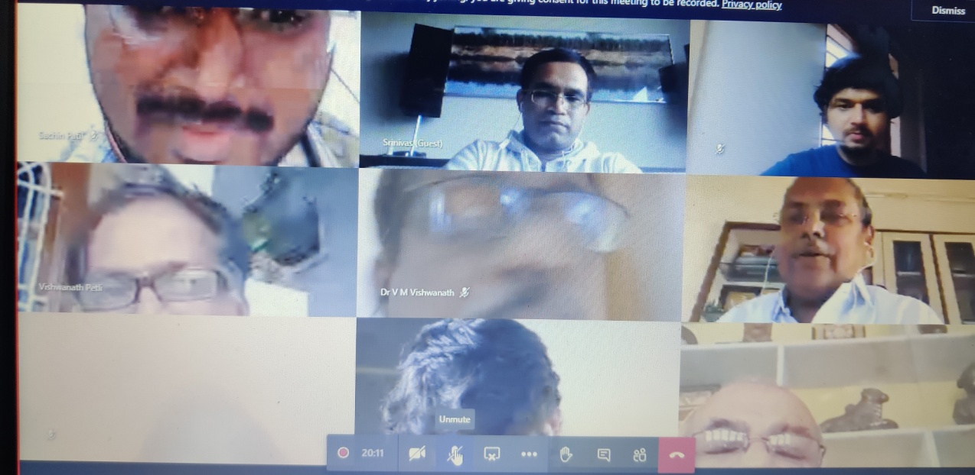
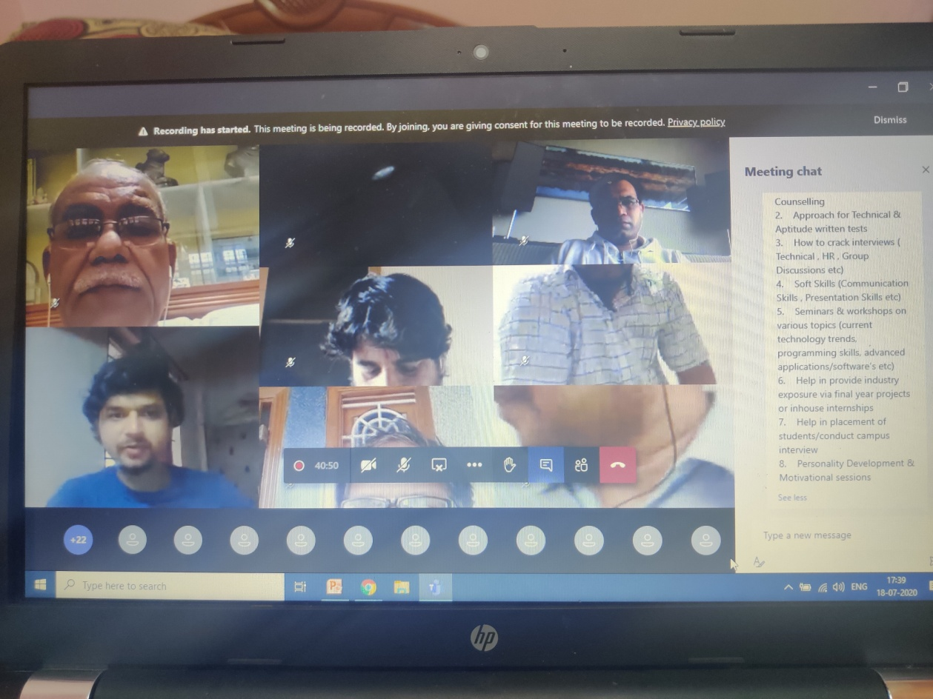

Suggestions from the Alumni for the development of Institution. Alumni members are suggested to:
- Contribution from alumni members.
- To establish an incubation centre in the institute
- Interaction with present faculties with passed out students.
- Conducting Job fair in Campus
- Services to college (Seminars, workshops and industrial visits).

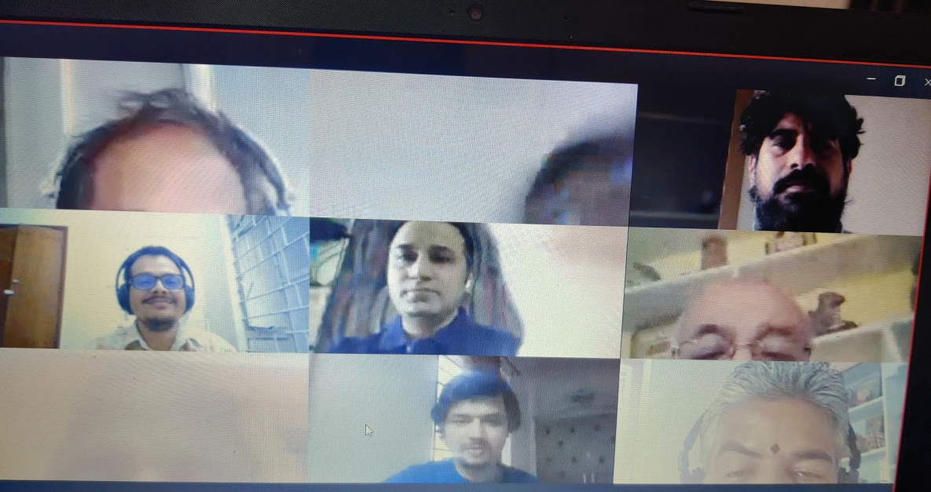

The meet was concluded by vote of thanks given by Prof. Vijayakumari G secretary of Alumni Association by thanking all the alumni and faculty members who were attended the meet for 2 hours.

